Cat Tinder

April 2022

# Product Overview

Cat Tinder is a full-stack project consisting of a React Front-End Framework mixed with a Ruby on Rails Back-end Management system. Website consists of 5 individual pages (including error page) with multiple additional pages for each cat in the database. Project took 6 days between 3 people culminating in a MVP in 46hrs of total working time.

## Front-end

### Design

Design began with a brainstorming/sticky note session followed by 3-4hrs of UX/UI research. Initial design was done by hand before being moved to Figma during planning stages. The project ultimately went through 3 redesigns before MVP was achieved. Multiple elements were created in Adobe Photoshop for this project.

### 

### Front-end Development

Front-end development was completed in React utilizing heavy CSS3 and HTML5 in both inline and separate file callbacks. Front-end connections predominantly made in React/Javascript while styling and layout divisions were coded in HTML/CSS.

## 

## Back-end Development

Back-end development was created using Ruby on Rails. Rails was established as the database management for this project due to functionality implementation with React. An API consisting of cat objects containing Name, Location, Age, Enjoyed Activities, and Profile Pictures, was created. After creation of the front-end application, the API was linked in order to provide dynamic membership abilities.

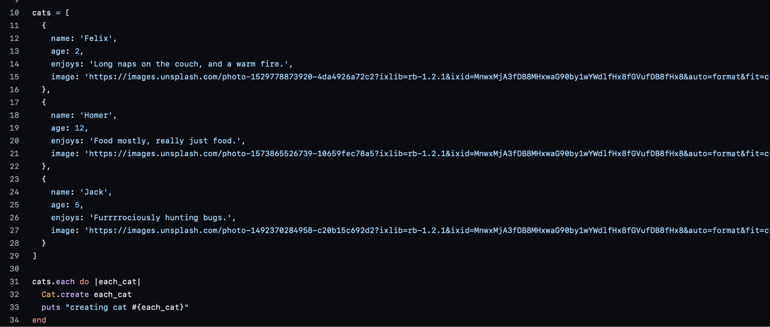

# Details

Cat Tinder was created as a multi-person project in a one week sprint as part of the Alpha 2022 cohort at LEARN Academy. While only achieving a MVP in the time, enough planning, design notes, and code snippets have been created to make a full-scale app post sprint if desired. While several blockages had occurred during the sprint, all priority issues were resolved before “launch”.